## Columbia University

**How to install Anaconda on Windows**

<https://www.anaconda.com/what-is-anaconda/>

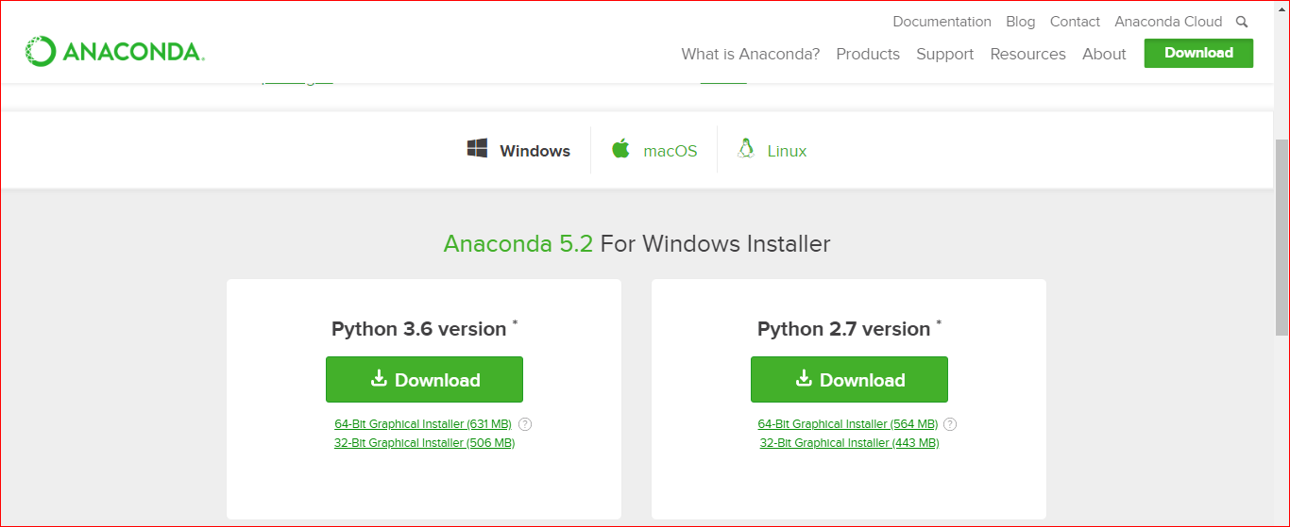

Durante el proceso de instalación, Habrá que seleccionar el PATH de la implementación de Python 3.5 en la carpeta del sistema.

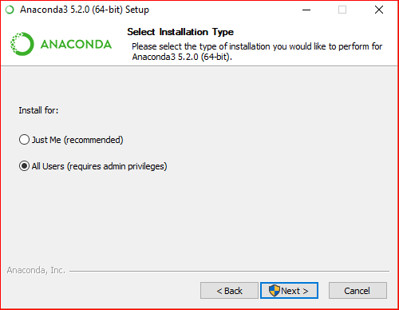 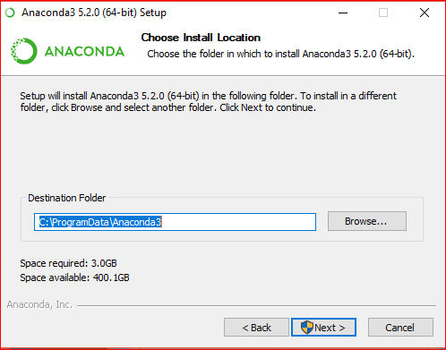

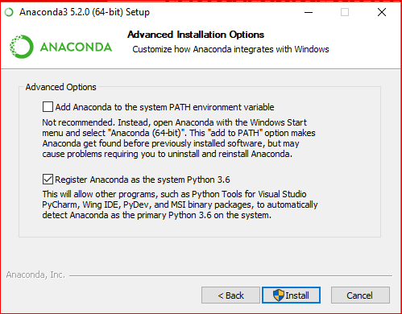 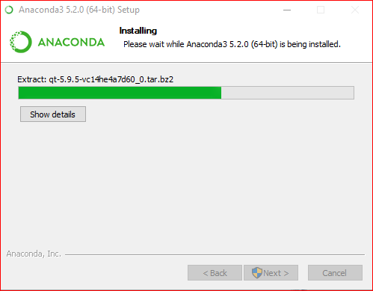

### Week1:

## 1.1 Python data types

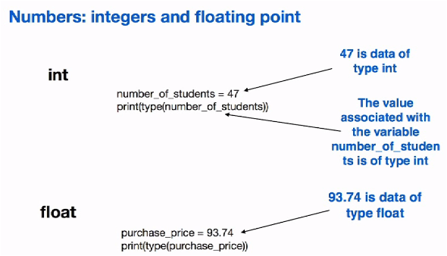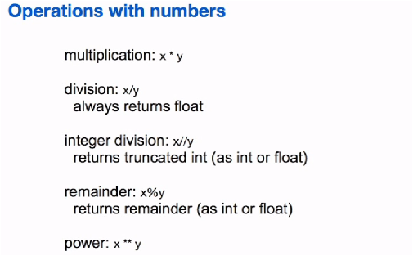

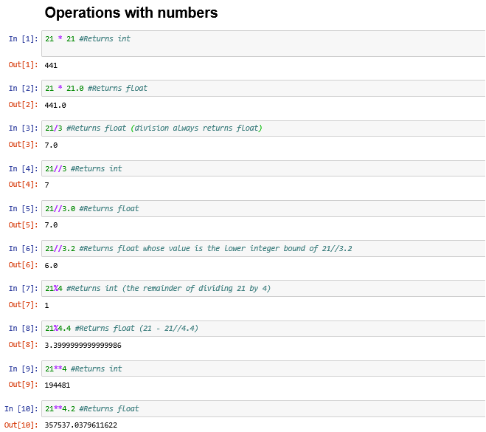

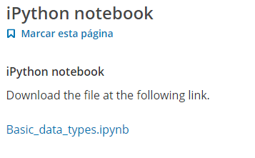

## 1.2 Strings in Python

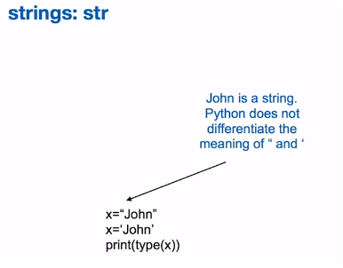 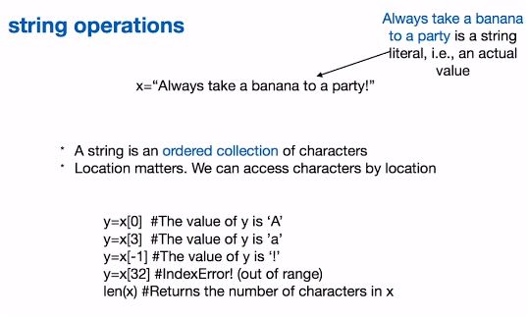

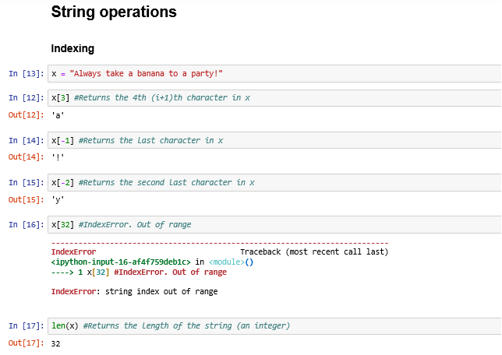

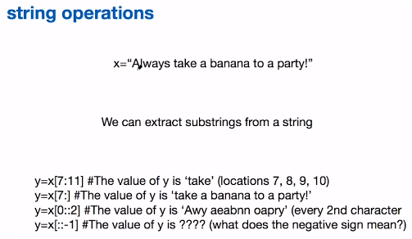

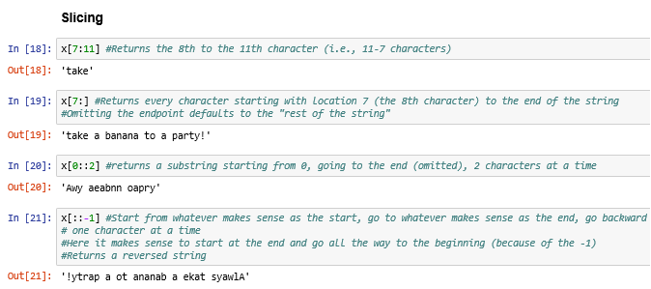

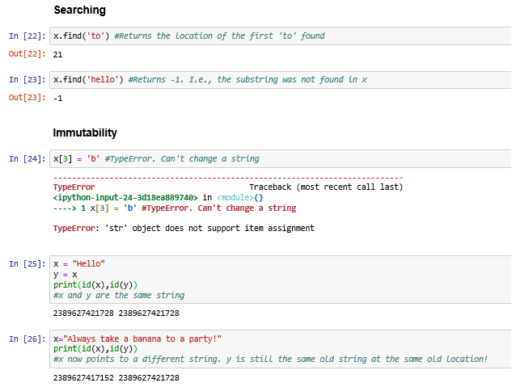

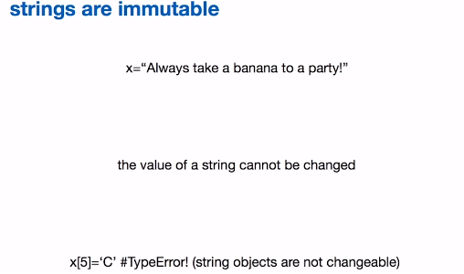



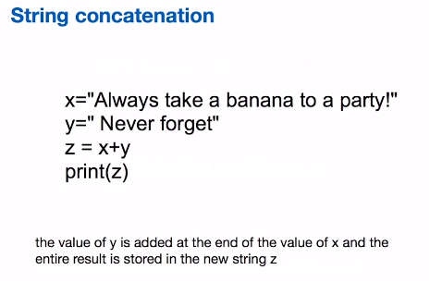

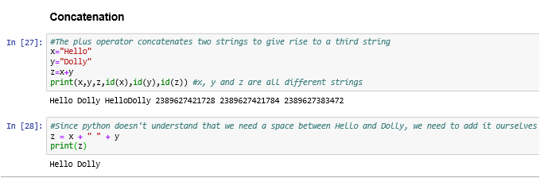

## 1.3 Variables and values

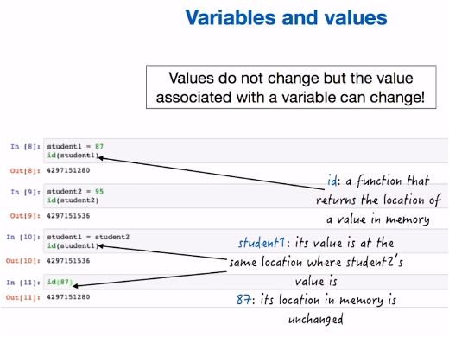

## 1.4 Boolean types in Python

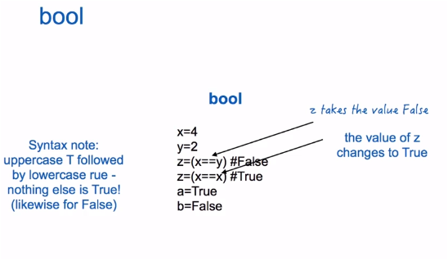

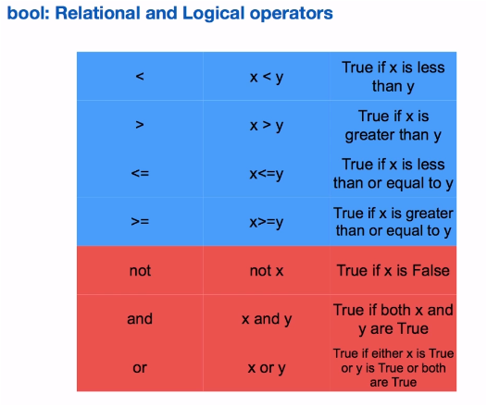

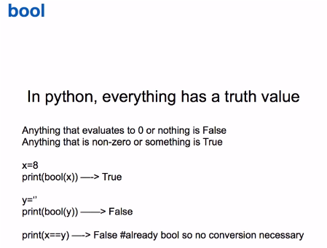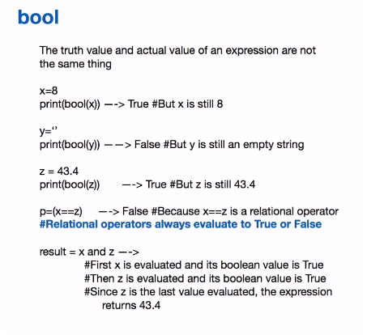

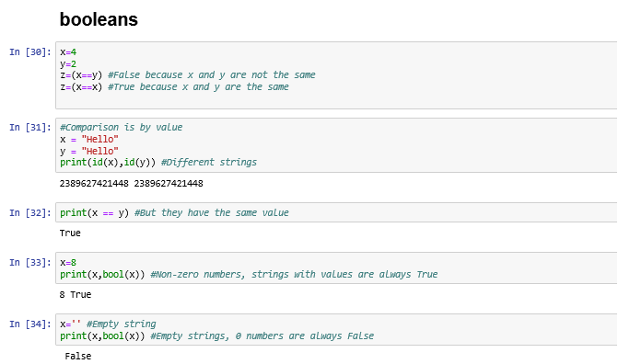

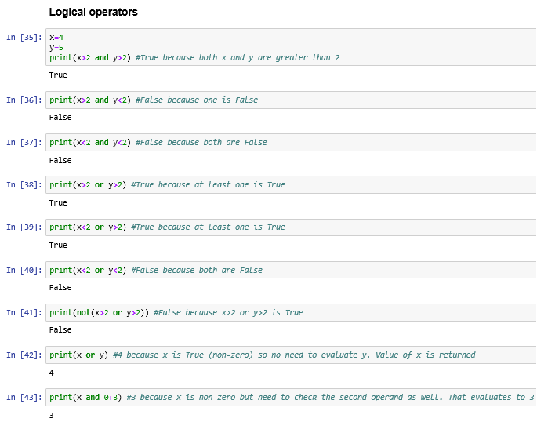

## 1.5 Assignment Operations

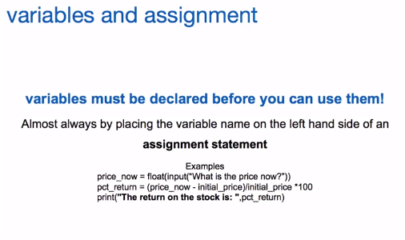

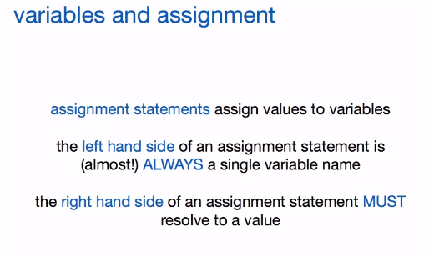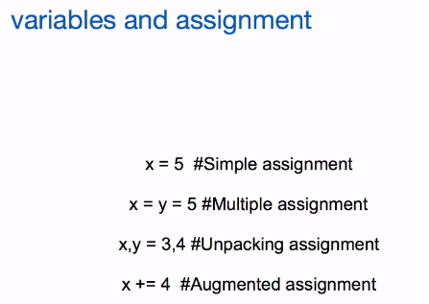

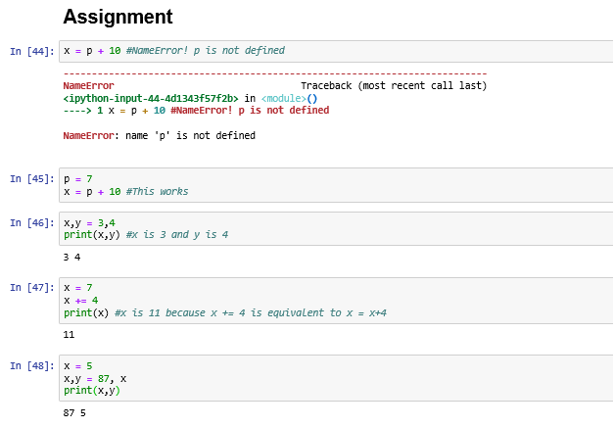

## 1.6 The if statement

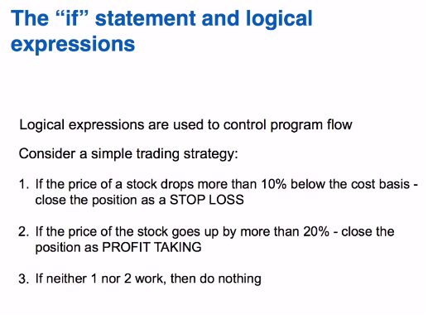

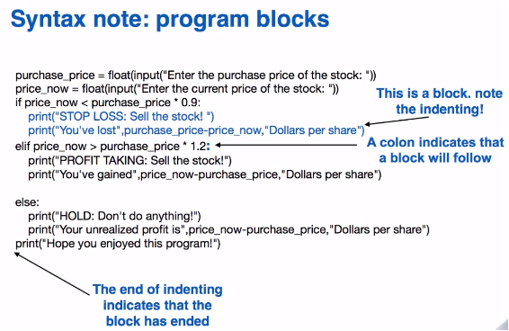

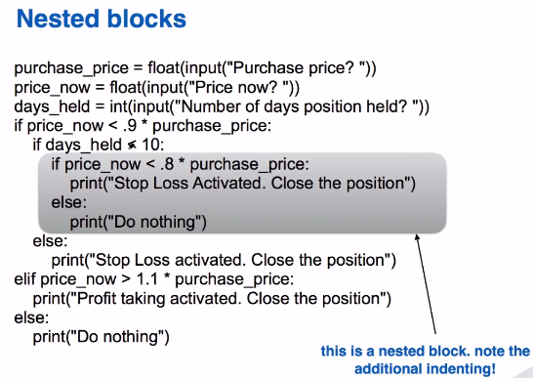

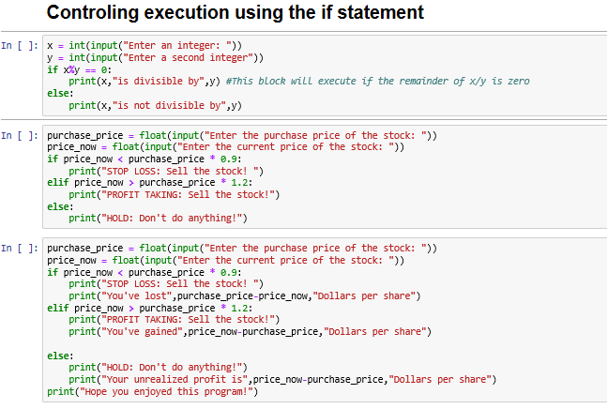

**Ejemplo:**

x = int(input("Enter an integer: "))

y = int(input("Enter a second integer"))

if x%y == 0:

print(x,"is divisible by",y) #This block will execute if the remainder of x/y is zero

else:

print(x,"is not divisible by",y)

**Ejemplo:**

purchase_price = float(input("Enter the purchase price of the stock: "))

price_now = float(input("Enter the current price of the stock: "))

if price_now < purchase_price * 0.9:

print("STOP LOSS: Sell the stock! ")

elif price_now > purchase_price * 1.2:

print("PROFIT TAKING: Sell the stock!")

else:

print("HOLD: Don't do anything!")

**Ejemplo:**

purchase_price = float(input("Enter the purchase price of the stock: "))

price_now = float(input("Enter the current price of the stock: "))

if price_now < purchase_price * 0.9:

print("STOP LOSS: Sell the stock! ")

print("You've lost",purchase_price-price_now,"Dollars per share")

elif price_now > purchase_price * 1.2:

print("PROFIT TAKING: Sell the stock!")

print("You've gained",price_now-purchase_price,"Dollars per share")

else:

print("HOLD: Don't do anything!")

print("Your unrealized profit is",price_now-purchase_price,"Dollars per share")

print("Hope you enjoyed this program!")

## 1.7 Functions (Part 1)

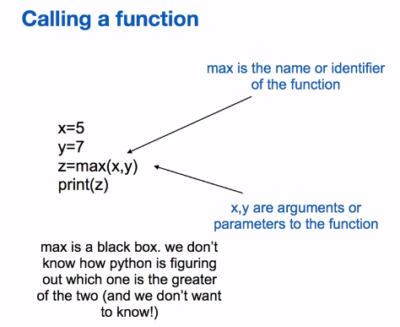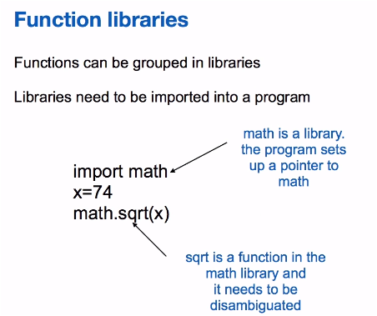

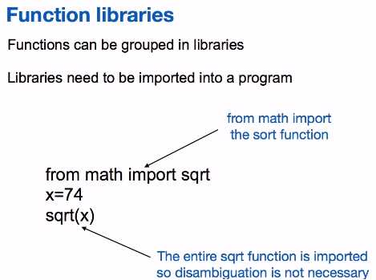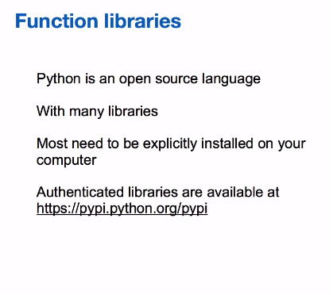

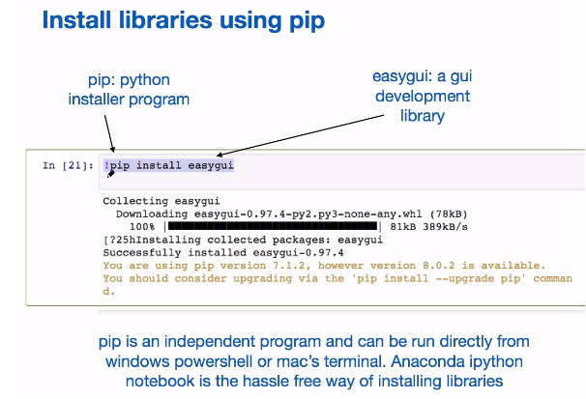

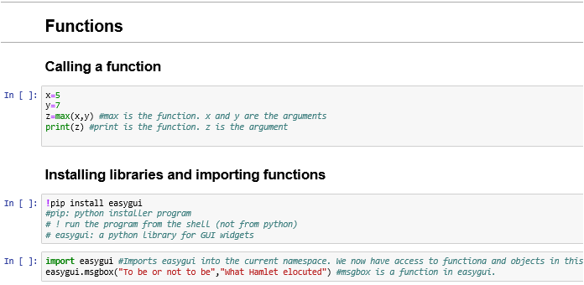

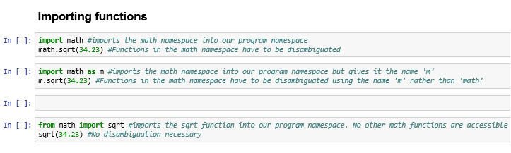

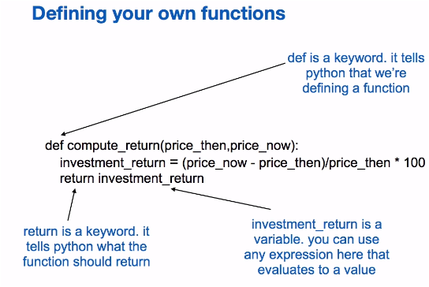

## 1.8 Functions (Part 2)

## 

## 

## 

## 

## 

## 

## 